Homework 5  
Statistical Inference

**PREPARED BY**

Mohsen Fayyaz - 810100524

Winter 2021

**فهرست مطالب**

**Q1** **3**

According to a 2012 survey of 2,254 American adults, 17% of cell phone owners prefer to browse on their phone rather than on a computer or other device. 3

**Q2** **5**

Some people report that just one sip can detect the difference between a diet and a regular soda. A researcher wanted to test this claim, so he chose 80 persons randomly. He then filled 80 simple white cups with Soda, half diet and half regular, and asked each person to take one taste from their cup and identify the Soda as diet or regular based on a random assignment. The drink was accurately identified by 53 of the participants. 5

**Q3** **6**

**Q4** **8**

**Q5** **11**

In Iran, an insurance company asked motorcycle and car drivers whether they prefer not to use their insurance to get a discount for next year or use the insurance to get their damage cost. A person can be a motorcycle driver or car driver in this poll, not both. Below is the distribution of responses by the driver's type. 11

**Q6** **12**

**Q7** **14**

**Q8** **16**

# Q1

## According to a 2012 survey of 2,254 American adults, 17% of cell phone owners prefer to browse on their phone rather than on a computer or other device.

a. According to an online article, a report from a mobile research company indicates that 38 percent of Chinese mobile web users only access the internet through their cell phones. Conduct a hypothesis test to determine if these data provide strong evidence that the proportion of Americans who only use their cell phones to access the internet differs from the Chinese proportion of 38%.



b. Interpret the p-value in this context.

As p is very small (<0.05) we reject the null hypothesis and accept HA which means that the data provides significant evidence that the proportion of American adults browsing on their phone is different than that of Chinese users.

c. Calculate a 95% confidence interval for the proportion of Americans who access the internet on their cell phones and interpret the interval in this context.



We are 95% confident that the proportion of American adults who browse on their cellphones is within our confidence interval.

# Q2

## Some people report that just one sip can detect the difference between a diet and a regular soda. A researcher wanted to test this claim, so he chose 80 persons randomly. He then filled 80 simple white cups with Soda, half diet and half regular, and asked each person to take one taste from their cup and identify the Soda as diet or regular based on a random assignment. The drink w as accurately identified by 53 of the participants.

a. Do these data show that these participants can tell the difference between diet and regular Soda, or, in other words, are the results significantly better than random guessing?

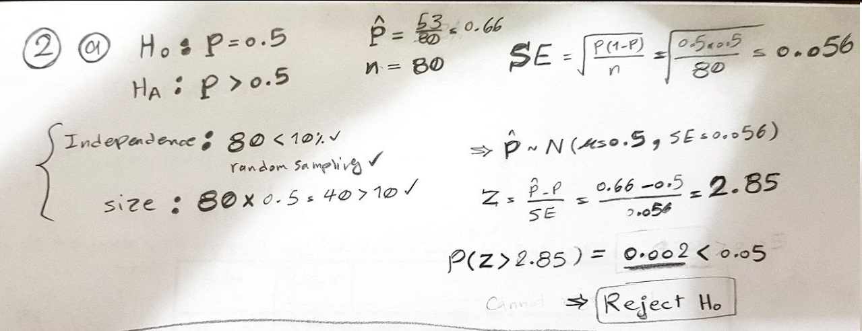

b. Interpret the p-value in this context.

As p-value is small (>0.05) we reject H0 and the data provides significant evidence that the proportion of people who can accurately identify is better than just a random guess (p=0.5).

# Q3

The US National Institutes of Health announced in July 2008 that it was terminating clinical research early due to unexpected results. The trial included HIV-positive women in Sub-Saharan Africa who were given a single dosage of Nevaripine (an HIV therapy) after childbirth to avoid HIV transmission to the baby. The trial compared the effects of continuing therapy with Nevaripine vs. Lopinavir, a second HIV medicine after a woman had a successful delivery. The trial included 240 women, 120 of whom were randomly assigned to one of the two therapies. Each woman was checked twenty-four weeks after starting the study therapy to see if her HIV infection was getting worse (an outcome called virologic failure). Twenty-six of the 120 women treated with Nevaripine developed virologic failure, compared to ten of the 120 women treated with the other medicine who experienced virologic failure.

a. Create a two-way table presenting the results of this study.

|  | **Nevaripine** | **Lopinavir** |  |
| --- | --- | --- | --- |
| **virologic failure** | **26** | **10** | 36 |
| **No virologic failure** | **94** | **110** | 204 |
|  | 120 | 120 | 240 |
| $\hat{p}$ | $\frac{26}{120}=0.216$ | $\frac{10}{120}=0.083$ | $\hat{p_{pool}}=\frac{total}{n1+n2}=\frac{36}{240}=0.15$ |

b. State appropriate hypotheses to test for difference in virologic failure rates between treatment groups.

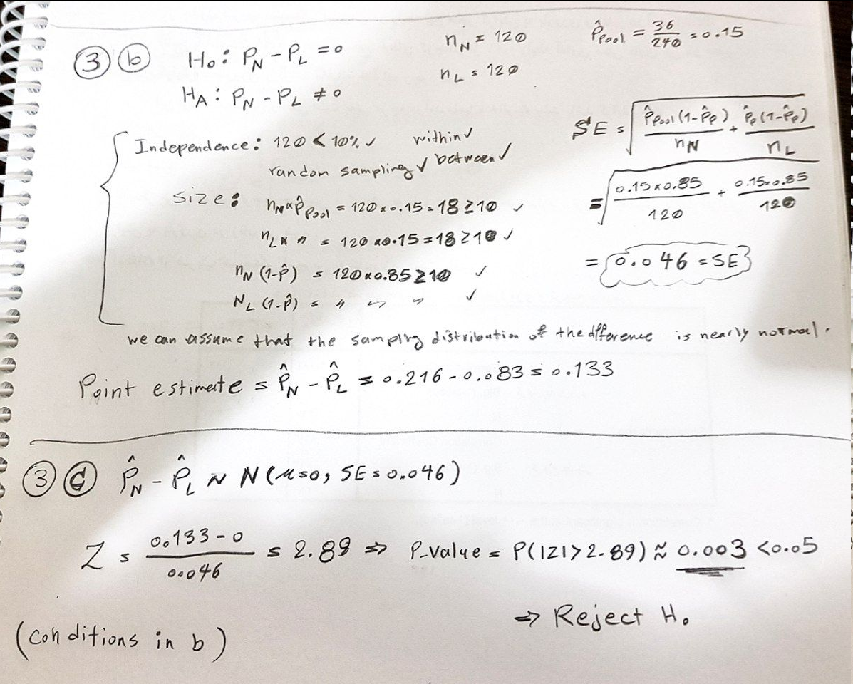

c. Complete the hypothesis test and state an appropriate conclusion. (Reminder: verify any necessary conditions for the test).



Conclusion: reject H0 which means the data provides significant evidence that the difference between these two rates is statistically significant.

# Q4

The National Center for Health Statistics (NCHS) provided data on the weight distribution (category) of Americans in 2002. This distribution is based on a specific value of Body Mass Index (BMI) calculated as the square of body weight (kilograms) and height (meters). Underweight was defined as BMI <18.5, normal weight was defined as BMI from 18.5 to 24.9, overweight was defined as BMI from 25 to 29.9, and obesity was defined as BMI over 30. Americans in 2002 were distributed as follows: 2% underweight, 39% normal weight, 36% overweight, and 23% obesity. Suppose you want to evaluate whether the BMI distribution is different in the Framingham Offspring sample. Using data from n = 3,326 participants who participated in the 7th examination of the descendants of the Framingham Heart Study, we created a defined BMI category and observed the following:

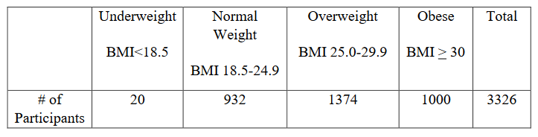

a. Set up hypotheses and determine the level of significance.

Goodness of Fit

H0: The observed counts of people from various BMI follow the same BMI distribution in the population.

HA: The observed counts of people from various BMI do not follow the same BMI distribution in the population.

We can use the 0.001 significance level.

b. Select the appropriate test statistic.

|  | Underweight | normal | overweight | obesity | Total |
| --- | --- | --- | --- | --- | --- |
| % in population | 2% | 39% | 36% | 23% | 100% |
| expected # | **67** | **1297** | **1197** | **765** | 3326 |
| observed # | 20 | 932 | 1374 | 1000 | 3326 |

We shall use the Chi-square Test.  
Conditions:  
1 Independence: Sampled observations must be independent.:

random sample/assignment ✓  
 𝑛=3326 < 10% of population ✓  
 each case only contributes to one cell in the table ✓

2. Sample size: Each particular scenario (i.e. cell) must have at least 5 expected cases. ✓

When dealing with counts and investigating how far the observed counts are from the expected counts, we use a new test statistic called the chi-square (𝜒2 ) statistic. $X^{2}=Σ\frac{(O-E)^{2}}{E}$

c. Set up decision rule.

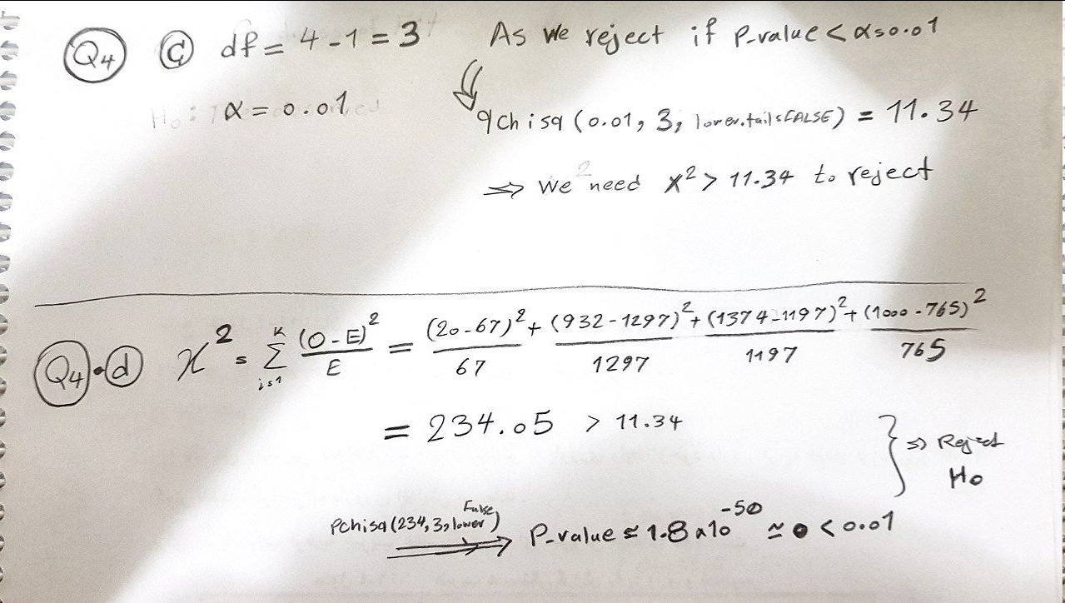

d. Compute the test statistic.



e. Conclusion.

As the p-value is small (<0.01) we reject the null hypothesis H0 which means the data provides significant evidence that these two BMI distribution are different from each other.

# Q5

## In Iran, an insurance company asked motorcycle and car drivers whether they prefer not to use their insurance to get a discount for next year or use the insurance to get their damage cost. A person can be a motorcycle driver or car driver in this poll, not both. Below is the distribution of responses by the driver's type.

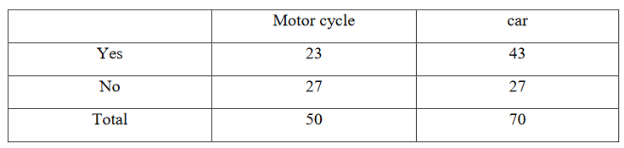

Is the proportion of these two different groups identical or not?

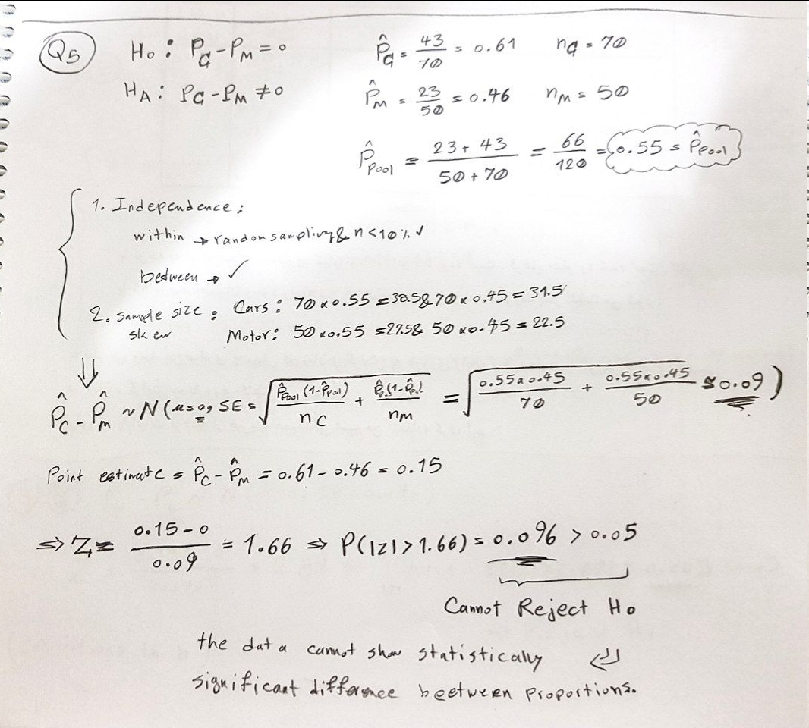

# Q6

**(R)** The experimenters investigated whether a mother can recognize the smell of her child. 26 practitioners of mothers were kept in an isolated room. The children were given to their mothers in order to be recognized. The mother should be able to identify her child's smell. There were a total of 320 trials, of which the mother correctly recognized her child's smell 110 times.

a. What is the null hypothesis, i.e., how often would we expect the participants to be correct by chance (in raw number and in percentage)?

H0: p=0.038, n=12.30  
HA: p>0.038, n>12.30

As there are 26 children, a random guess will be 1/26=0.038 correct, which in raw number will be $\frac{1}{26}*320=12.30$.

b. Using a chi-square test, what do you conclude about whether mothers recognize their child's smell?

|  | correct | false | Total |
| --- | --- | --- | --- |
| % in population | 3.8% | 96.2% | 100% |
| expected # | **12** | **308** | 320 |
| observed # | 110 | 210 | 320 |

H0: the distribution between true and false follows the same distribution of random choice.  
HA: the distribution between true and false does not follow the same distribution of random choice.

Conditions:

1. Independence: Sampled observations must be independent. random sample/assignment if sampling without replacement, 𝑛 < 10% of Population each case only contributes to one cell in the table ✓

2. Sample size: Each particular scenario (i.e. cell) must have at least 5 expected cases. ✓

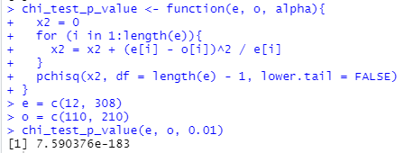

As shown, the p-value is very small therefore we can reject the null hypothesis which means the data provided significant evidence that the mothers are doing much better than random guessing.

# 

# 

# Q7

**(R)** Consider the dataset named "caith" in the "MASS" library. Caith consists of 4 rows of eye colors: blue, light, medium, and dark and 5 rows of hair colors: fair, red, medium, dark and black. Test the hypothesis of whether the eye color is independent of the hair color at a .05 significance level. calculate the expected value.

Chi-square test of independence:

1. Independence: Sampled observations must be independent. random sample/assignment if sampling without replacement, 𝑛 < 10% of population each case only contributes to one cell in the table ✓

2. Sample size: Each particular scenario (i.e. cell) must have at least 5 expected cases. ✓

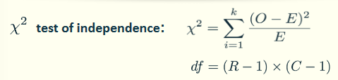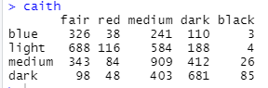

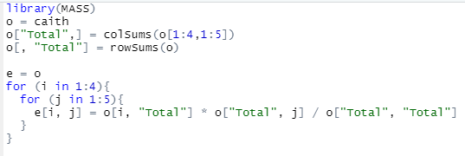

# 

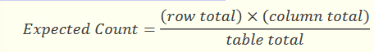



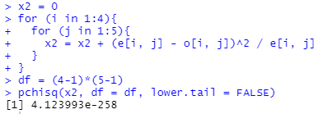

As shown, the p-value is very small (<0.05) therefore we can reject the null hypothesis which means the data provided significant evidence that eye and hair color are dependent.

# Q8

**(R)** An experiment was done to check the temperature required to damage a computer system. This experiment is important for computer servers to keep them in a good environment. Because of the price of testing, twenty computers were tested to see what temperature would damage the computer. In this test, all of the computers were damaged in more than 110 degrees. Perform a hypothesis test for the variable's success rate by means of the simulation method.

𝐻0: 𝑝 = 0.5  
𝐻𝐴: 𝑝 > 0.5  
𝑛 = 20 , $\hat{p}$ = 1



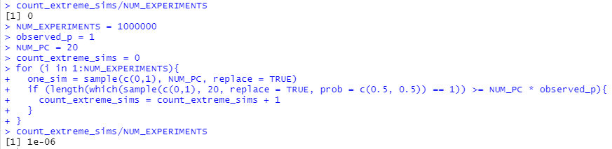

As the p-value is very small (<0.05) therefore we can reject the null hypothesis which means the data provided significant evidence that temperature more than 110 degrees damages computers.